# Assignment Structure

The case study for this assignment (see CP4P_Final_Assignment Case Study.docx file) and its deliverables are representative of many ICT projects. The project management artifacts – Proposal, Budget, and WBS – are standard practice. You might very well have to write, review, and/or evaluate them in your future IT career. (what COM101 and EAC397 are good for)

**Your team is bidding on – *not doing* –** **a potential client's internal IT infrastructure upgrade project as described in the case study. Your boss (instructor) has assigned your group the task of responding to the potential client's** [**Request For Proposal**](https://en.wikipedia.org/wiki/Request_for_proposal) **(RFP).**

You will start by developing an Assignment Plan for your team to create a Project Proposal, Budget, WBS–Work Breakdown Structure (two person groups), and a Training Module (three person groups). These artifacts, as they are called in project management, are your response to the client's RFP and will be submitted to the client for their evaluation. The client will decide if your team will be selected to do their project based on how well your artifacts convince them that you understand the client's needs, know how to provide a solution for their needs, and have the project management skills to successfully deliver it.

All students in your group will get the same project mark. Groups can have problems, you are working with other people after all. Many problems proceed from splitting up the work into individual assignments (siloed tasks with last minute mashup). Many problems are avoided by sharing the work as follows.

**Everyone completes a rough/high-level draft of all artifacts.** Circulate the drafts for review. The group meets to combine the drafts into outlines. Set S.M.A.R.T. goals in assigning tasks to deliver the artifacts (see the Assignment Plan document). If everyone cooperates for the sake of the project, not individual benefit, then everyone will benefit: the whole will become more than the sum of the parts.

It is expected that each group will attempt to solve their own problems before asking the instructor for assistance / mediation. A Problem Report can be filed for unresolved group issues (marks may be allocated based on individual contribution to the project).

Although class time is allocated to work on the Assignment, your group may need to meet outside class to complete the Assignment tasks.

See this: a good Project Manager [makes group projects more efficient](https://getpocket.com/explore/item/how-managers-can-make-group-projects-more-efficient) (and less painful).

# Project Deliverables and Specifications:

Office 365 **Teams** has become an industry standard collaboration environment to develop projects. Teams is the shared repository for your project artifacts.

Sign on to mySeneca.ca,

* from the grid menu, start the Teams app,   
  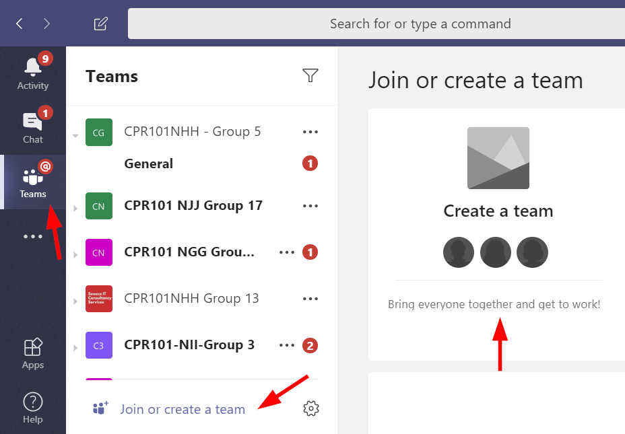
* Join or create a team, team type is Other.  
  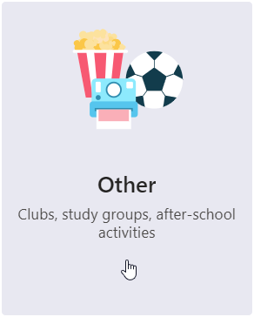
* Near the bottom of the "Create your team" dialog, select the link to   
  Create a team using an existing team as a template  
    
  Which team do you want to use as a template? **CPR101AZZ 99**  
  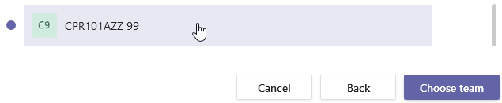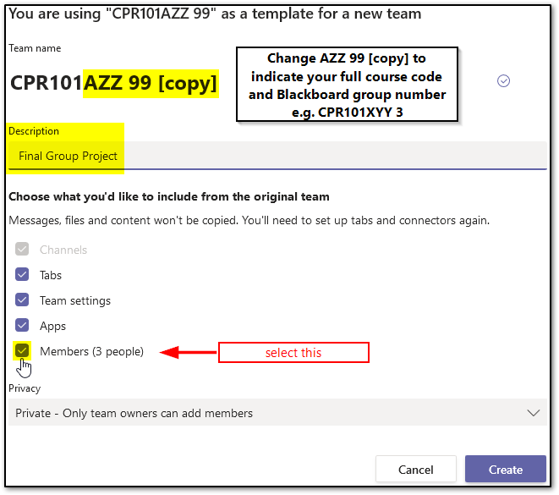  
  Change the team name from **CPR101*AZZ 99 [copy]*** to indicate your full course code and Blackboard group number: e.g. **CPR101XYY 3**
* Team name: full course code and Blackboard group number  
  e.g. CPR101**AZZ** **99**
* Description: Final Group Project
* Privacy: Private - only team owners can add members
* Add a member by typing their Office 365 name
* Add your Blackboard group members
* Add your instructor.   
  Change your instructor's Role from Member to Owner.
* To [remove someone from a team](https://support.microsoft.com/en-us/office/remove-someone-from-a-team-91610d8b-c182-4cab-8f31-1ed8d3d316ee), their Role must be (changed to) Member, click the X to the far right of the name.

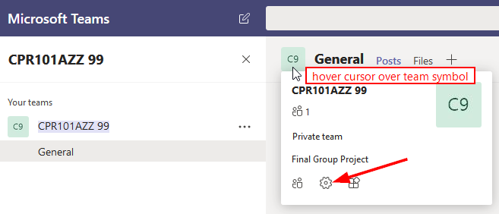  
The Teams environment has two default tabs for…

* Posts: communications and commentary on the project and file contents will be shown in here.
* Files: Use the top level for files that are project artifacts also called deliverables; e.g. Word and Excel files.
  + By always using the same file names, Teams & SharePoint (AKA OneDrive for Business) will take care of version control/history.
  + SharePoint maintains files' version history (open in SharePoint and hover pointer over file name, click the three vertical dots to reveal menu).
* Using New, add a Folder called **Development** within Files
* it will contain everything that is not a project artifact, e.g. case study notes. This will keep the deliverables separate from the development process.

|  |  |
| --- | --- |
|  | Please do not use Chat to contact your instructor – use Teams (see below) or email for private messages. Feel free to use Chat amongst yourselves. |
|  | Please keep all communications with your instructor in the Teams General channel. Use @Instructor_Name to get their attention. |
|  | For communications on a specific artifact, click on the file under Files and Start or continue the conversation. Use @Name to get the attention of your instructor to team member. |

Nomenclature

"Client" is the case study company you are preparing the Proposal, etc for.

"Customer" is the case study company's customers who have accounts or portfolios with them.

**Deliverable #1 – the Assignment Plan – post to the Teams site** – for all groups regardless of size.

Your group's first task is to create the “Assignment Plan.docx”. It describes the group’s team name (includes your course's section code "XZZ" and Bb group number), a link to the Team (under ••• menu), its members, and how the work is shared and assigned to create the artifacts and complete the assignment.

This is the initial plan of who does what based on your best guess of the work to be done to achieve the deliverables. It should be revised and edited as the project progresses. By the time of final submission, it will show details of who did what, both planned and completed, with estimated and actual hours. It is your teams work breakdown structure to accomplish the assignment; the assignment is not just academic, it is very similar to the professional activities and tasks frequently done by IT consultants who routinely respond to RFPs as a way of getting business for their company.

Send a Team note @your.instructor to review this deliverable.

**Deliverable #2 – draft Proposal, WBS, Budget.** – for all groups regardless of size. **+ *outline* of one training module for 3 person groups  
+ *outline* of two training modules for 4 person groups**

Your group’s Proposal to the case study company (your client) sets expectations for the project. The proposal addresses the client's problems, the business benefits the client is seeking, the work your team will perform for the client that will enable those benefits, the estimated costs, and a demonstration that you understand the details of the work to be done along with the project management skills to do it. **A proposal template document is posted on Bb.**

The Proposal is a summary of the project with your estimate of the work to be done, costs, and phases or sub-projects.

The proposal’s Background section assures the client that you understand their business problem. You do that by reflecting it back to them. It usually opens with relevant business history and a problem statement. What circumstances caused the business to request this proposal from you? 🡺 summarize the client’s problems found in the case study.

The Objectives section lists the client’s anticipated business benefits and project success criteria. 🡺 *After* the Scope of your work is done, what benefits will accrue to the company? What will the client gain by the end of the project? How will their business operations be better?

The Statement of Scope (SoS) is a summary of the products and/or services your team will deliver to satisfy the business objectives. It includes a high-level list of the features and functions the client's business will gain as a result. 🡺 The scope is what you will do: what is included and how your work will be implemented and deployed. The SoS defines and controls what work is *and is not* included in this proposal for the project. Items essential to the success of the project but not within the SoS are stated as necessary conditions, e.g. pre-existing infrastructure such as LAN/WAN or client supplied/contracted IT services such as IBM’s web hosting and cloud storage services.

Avoid TLAs in any communications with the client.

1. Prepare a [Work Breakdown Structure](http://www.brighthubpm.com/templates-forms/2645-what-is-a-work-breakdown-structure/) ([WBS](https://www.teamgantt.com/blog/how-to-estimate-projects-accurately-using-a-work-breakdown-structure)) of the client’s project. Prepare a list or chart showing the project's detailed tasks in sequence, the estimated hours to complete, if the task is dependent upon another task being finished before this task can be started, and the skill level needed to complete each task.   
     
   The WBS is a centrally important artifact. It supports the contents of Proposal and the Budget. The WBS provides:  
   * the detail to support the Statement of Scope in the Proposal.   
   * the critical path to calculate calendar start/end dates of the Proposal's Project Stages and Milestones.   
   * hours and skill levels used by the Budget to calculate Services costs.  
     
   e.g. WBS = tasks and sub-tasks to do. "Install server" can be a big or little task. The WBS 'breaks down' the big chunks of work into small packages of work which can be assigned to a person. In this case study, there are many separate things to be done to make the server ready for use: initialize OS, install business app package, create and test API with IBM, create 3-2-1 backup plan, configure file serving folders.  …and so on for all the work steps -- describe **what** needs to be done in enough detail for an experienced person who has the skill to do it. Then, estimate the hours needed for each **what**. Determine the sequence needed, decide which tasks are independent and can be done in parallel, which tasks must be serially (dependent on the completion of other tasks); finally, which tasks are repeated. (Like programming, there are three kinds of logic: sequential, decision/conditional, iterative/looping.) The longest series of serial tasks is your critical path which determines start and end dates of each phase or stage of the project (assume an 8 hour work day).  
     
   Although you may have to hire people to complete the project, that hiring process is NOT part of the client's project. It is part of your consultancy's operations overhead. You can charge project management hours to the client's Services budget.
2. Prepare a detailed cost estimate of the project to support the Project Proposal’s summary of costs and budgets.   
   Use the WBS hours and skill levels to support the labour and services costs shown in the budget.  
   For the hardware, do some research and use real costs. **Dell.ca** offers information on Advanced Tower Servers. Server must include a RAID 5 storage controller (e.g. 4 identical drives: 3 drives for approx. 2TB of data storage + 1 drive for the RAID 5 parity). RAID-5 runs by itself if configured as a server hwr option; it needs no configuration. Note that RAID is for *data integrity & reliability*, it is not backup, it is still your #1 copy.  An LTO tape drive would be a sensible thing to include for #2 copy. IBM cloud would work for #3 copy. The server OS can be your choice of Microsoft or Red Hat Enterprise.  
   Obtain new desktops for users with large screens, keyboards, and mice.   
   Include configuration details of the server and PCs in the budget. ("Server $10,000" will raise a lot of questions.)  
   N.B. Business proposals & budgets almost always omit / ignore sales taxes. Value added taxes like GST/HST make sales taxes paid on purchases an input tax credit to GST/HST collected on sales. Thus, it becomes an accounting exercise affecting only cash flow (not your problem).

Send a Team note @*your.instructor* to review this deliverable.

**Deliverable #3 –** **client's end user Training Module(s) – for groups of 3 or 4**

**For 3 person teams: create a two minute Training Module (instructional video or narrated PowerPoint / Adobe Spark presentation) on any course topic you feel would benefit end users.**

**For 4 person teams: create TWO Training Modules.**

If a **video** is used,it must be in H.264 MPEG-4 .MP4 file format which can be streamed and rendered by all browsers. Other formats may require software installation or a trip to planet Apple. Users do not care if it plays on your system, they care only about their systems.

The IT industry regularly uses this type of just-in-time user education resource. For example, the client’s new business application package would come with numerous short presentations and screen capture tutorials on all aspects of using the application.

The audience will be the end users (company employees). Anything you might explain to end users in a few minutes to make them more productive with technology is a fair topic. We have covered many things in our course from the POV of IT professionals. Some of those topics affect end users and can be explained from their POV. e.g. a short PowerPoint to orient the client's users to the new Windows 10 OS and differences with Windows 7. How to create a good password. Saving office files on the new server (e.g. set up a mapped network drive) so their data is safely backed up. Consider: Why would users invest their time to watch it? To make their lives easier and better is why.

The presentation must be an original work (you cannot use a completed YouTube or other video as part of your presentation). It requires voice over by one or more group members. Do **not** use music; in this type of instructional presentation, music is almost always a distraction from the voice-over (no need for a soundtrack to cue emotion) and/or an annoyance (not everyone likes the music you like). The presentation can use slides, [animation](https://www.google.ca/search?q=video+animation+maker), [screen](https://www.google.ca/search?q=screen+capture) [shots](https://www.take-a-screenshot.org/), [screen recording](https://www.google.ca/search?q=screen+recording), and/or live action. Avoid displaying a screen with large amounts of text — a text crawl is allowed only when starting a Star Wars movie. Summary bullet points and/or images are fine to support voice over.

Sources must be cited and referenced for any concepts, text, or images used in the project. Do that at the end of your presentation.